**OPERATING SYSTEM - CS23431**

**EXP 12**

**FILE ORGANISATION TECHNIQUE – SINGLE AND TWO LEVEL DIRECTORY**

**NAME: V.MAHALAKSHMI ROLL NO: 230701171**

**PROGRAM:**

**Single level directory:**

#include <stdio.h>

struct directory{

char dname[20];

char fname[10][20];

int f_count;

};

int main()

{

struct directory d;

printf("Enter directory name: ");

scanf("%s",d.dname);

printf("Enter number of files in the directory: ");

scanf("%d",&d.f_count);

printf("Enter names for files:\n");

for(int i=0;i<d.f_count;i++)

{

printf("Enter name for file %d: ",i+1);

scanf("%s",d.fname[i]);

printf("\n\t\t%s\n",d.dname);

for (int j = 0; j <= i; j++) {

printf("\t\t |\n");

printf("\t\t --> (%s)\n", d.fname[j]);

}

printf("\n");

}

return 0;

}

**OUTPUT:**

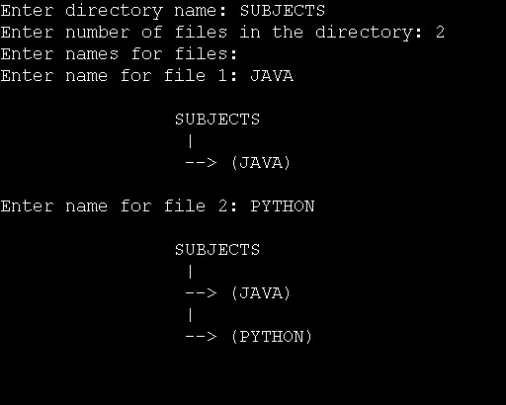

**Two level directory:**

#include <stdio.h>

#include<string.h>

struct directory{

char dname[20];

char subnames[10][20];

int sub_count;

};

int main()

{

struct directory d;

struct directory sub[10];

printf("Enter the name of dir/file(under null): ");

scanf("%s",d.dname);

printf("How many users(for %s): ",d.dname);

scanf("%d",&d.sub_count);

for(int i=0;i<d.sub_count;i++)

{

printf("Enter the name of dir/file(under %s): ",d.dname);

scanf("%s",d.subnames[i]);

printf("How many users(for %s): ",d.subnames[i]);

scanf("%d", &sub[i].sub_count);

strcpy(sub[i].dname, d.subnames[i]);

for (int j = 0; j < sub[i].sub_count; j++) {

printf("Enter name of dir/file(under %s): ", sub[i].dname);

scanf("%s", sub[i].subnames[j]);

}

}

for (int i = 0; i < d.sub_count; i++) {

for (int j = 0; j < sub[i].sub_count; j++) {

printf("\t\t | %s |\n", d.dname);

printf("\t\t |\n");

printf("\t\t | %s |\n", sub[i].dname);

printf("\t\t |\n");

printf("\t\t ( %s )\n", sub[i].subnames[j]);

}

printf("\n");

}

return 0;

}

**OUTPUT:**

